Dissertation Proposal Document
Theory leads to understanding, and technology development leads to discovery. One example is the work recognized by the 2020 Nobel Prize in Physics for the discovery of a supermassive compact object at the center of our galaxy, the supermassive black hole (SMBH) Sagittarius A*. Theory provided the framework for understanding the existence of an SMBH at the Galactic Center, while the development of telescopes and infrared detectors enabled observations of stellar orbits near Sagittarius A* and provided compelling evidence for its presence. The same relationship between theory, technology, and discovery will be important in the search for habitable worlds. Theory suggests that the conditions that led to life on Earth may exist on other planets around other stars, while improvements in detectors, telescopes, coronagraphs, and spectrographs have increasingly enabled the study of exoplanets and their atmospheres.
The Habitable Worlds Observatory (HWO) will build on these advances to address some of the largest astrophysical questions of this decade: Is there life on other planets? What are the drivers of galactic growth? What is the evolution of elements over cosmic timescales? How does the Solar System compare with other stellar systems? Answering these questions will require exquisite technologies capable of achieving the sensitivity and stability necessary for HWO observations. As the HWO Technology Maturation Program Office begins activities to ensure mission success, NASA, industry, and academic institutions are developing and characterizing technologies that may enable these observations.
As part of this effort, and supported by multiple NASA grants, I am characterizing and developing CMOS single-photon counting detectors (SPCDs). Specifically, I am working with the Fairchild Imaging HWK4123 CMOS SPCD. The central question motivating this work is whether CMOS SPCDs can achieve the performance required for HWO. Addressing this question requires understanding the current performance of state-of-the-art CMOS SPCDs, identifying previously uncharacterized behaviors and limitations, determining whether detector performance can be improved, and investigating computational methods that can improve the final results of data reduction.
To establish the current performance of the HWK4123, we have led an extensive characterization campaign. We have measured dark current, read noise, crosstalk, conversion gain, floating diffusion capacitance, quantum efficiency, persistence, and have conducted radiation exposure and on-sky observing programs. We are investigating additional detector behaviors and analysis methods, including low-signal nonlinearity, glow, quantum yield, and the impact of applying a rounding step during data reduction. The following sections introduce the detector technology, present the characterization results, and describe the remaining work of this thesis.
- Technology Introduction
The HWK4123 is a CMOS SPCD using five-transistor (5T) pixels. Each pixel has a pinned photodiode (PPD) that collects photoelectrons and five transistors that control charge transfer and readout. First, the transfer gate (TG) is turned on to transfer any unknown charge from the PPD to the floating diffusion (FD) while the reset gate (RG) resets the voltage on the FD. The TG is then turned off, followed by the RG, so that the voltage on the FD is the reset-level voltage. The pixel is now prepared for the reset-level measurement of the voltage on the source follower (SF), which follows the voltage level of the FD. The reset-level measurement is the first of two in the correlated double sampling (CDS) sequence. When this first measurement is completed, the pixel is now entering the integration phase. The pixel accumulates photoelectrons in the PPD during integration. When integration is completed, the TG once again transfers charge from the PPD to the FD. The signal of the SF, which is coupled to the voltage of the FD, is measured and provides the second measurement of the CDS sequence. This completes one measurement cycle for the pixel, from which the cycle begins again at the start of this paragraph.

The reason why these detectors are able to count single photons is because they have a FD capacitance that is very small, and this produces a voltage response to a single charge carrier that far exceeds the voltage level of the read noise of the pixel. As such, we are able to produce a photon counting histogram for repeated signal samples, for every pixel. The PCH has a series of distinct features corresponding to resolved electron numbers. Each feature is an ensemble of signal samples that are assigned to a specific electron number but span a width in values expressed in analog-to-digital units (ADUs). This width depends primarily on the read noise. In fact, read noise affects the bit error rate, which is the probability of assigning the wrong electron number to a measurement.24,25 The separation between the centers of these features depends on the system conversion gain (ADU∕e−). Therefore, a PCH shows resolved electron numbers for low read noise detectors with high conversion gain.

CMOS SPCDs, and the HWK4123 specifically, have become increasingly relevant in astrophysics. Multiple ground-based observatories have adopted the HWK4123, such as VAPMIRES on Subaru, Clay Magellan, Ben’s telescope, and others. Furthermore, it has been selected for the upcoming Lazuli Space Observatory. Clearly, CMOS SPCDs perform similarly to other SOTA silicon-based detectors, such as electron multiplying charge-coupled devices (EMCCDs) and skipper CCDs. Table 7 presents the performance of different CMOS SPCDs, EMCCDs, and skipper-CCDs.
The following section compares the measured performance of the HWK4123 to the current HWO specifications at Technology Readiness Level 5 and contextualizes the HWK4123 with other state-of-the-art detectors in the NUV/visible and visible range, listed in Table7. The HWK4123 performance values partially satisfy HWO’s current detector specifications. The DC and RN are well below the NUV/visible specifications but are ∼5× and ∼2× larger than the threshold for the visible range coronagraph, respectively. The HWK4123 QE satisfies the visible range specifications from 410 to 570nm. We provide suggestions to improve DC, RN, and QE in Sec.5.2. The HWK4123 performance is comparable to the QIS, EMCCDs, and skipper-CCDs for the values listed in Table7. However, skipper-CCDs can read nondestructively and lower the read noise of a measurement with correlated multiple sampling. The pixel architecture of the HWK4123 does not permit nondestructive reads, but future CMOS SPCD designs can account for this. It is important to consider other detector performance metrics beyond those compiled in Table7, such as the detector operating conditions, the pixel and readout architecture, and noise specific to a technology. CMOS SPCDs offer significant advantages over EMCCDs and other photon-counting technologies for space instruments. CMOS SPCDs have deep sub-electron read noise through small-capacitance sense nodes and direct-readout architectures. 67,68 This enables single-photon detection and photon-number resolution at room temperature without requiring avalanche gain. 69 Unlike CCD technologies, CMOS devices use a direct-readout architecture that eliminates pixel-to-pixel charge transfer. This avoids radiation-induced charge transfer inefficiency, which is critical for long-duration NASA missions in high-radiation environments, such as L2 or the Jovian system. 68,70,71 In CCDs, radiation-induced traps capture and release signal charge during transfer, causing image trailing, flux loss, and systematic errors, particularly for faint objects. For example, radiation-induced charge traps within the Hubble Space Telescope’s Advanced Camera for Surveys Wide Field Channel capture and release signal charge during pixel-to-pixel transfer.72–74 This disproportionately affects the pixels farthest from the readout amplifier, which need more transfers to read out charge and lose more than 50% of their electrons under faint observing conditions. CMOS SPCDs avoid these effects throughout the mission lifetime without requiring complex correction algorithms. Compared with EMCCDs, CMOS SPCDs provide single-photon sensitivity with higher radiation tolerance and simpler operation. EMCCDs amplify signal electrons via a high-voltage gain register, which is vulnerable to radiation damage and single-event transients. EMCCDs also experience gain aging, clock-induced charge, and radiation-induced charge transfer inefficiency, all of which reduce quantitative photon counting over time.68,70,71 CMOS SPCDs achieve photon sensitivity through high conversion gain at the pixel level, preserving Poisson statistics, supporting high frame rates, and operating near room temperature without excess noise or long-term degradation. EMCCDs and skipper CCDs have clock-induced charge (CIC) and charge transfer inefficiency, rely on serial charge transfer and off-pixel amplification, and consume more power to operate. In EMCCDs, CIC is amplified by the electron-multiplying stage. The CIC reported for the EMCCDs and skipper-CCDs in Table 7 ranges from 0.003 to 0.0009 e−∕pixel∕frame.58,59,63,64 Relative to single-photon avalanche diodes, microwave kinetic inductance detectors (MKIDs), transition-edge sensors (TESs), and superconducting nanowire detectors (SNSPDs), CMOS SPCDs balance performance with system-level feasibility. Superconducting and avalanche-based detectors can achieve exceptional timing resolution and low dark counts but require cryogenic systems, specialized electronics, and smaller pixel formats. These requirements increase instrument cost, mass, and integration complexity, particularly for wide-field imaging. CMOS SPCDs stand apart not only for photon-counting sensitivity and radiation resilience but also for their system-level integration. Unlike other detector technologies that require extensive off-chip electronics, cryogenic cooling, or complex biasing, CMOS SPCDs incorporate the entire readout
t ecosystem on-chip, including power regulation, clock generation, programmable readout modes, and digitization. This system-on-a-chip approach reduces instrument size, weight, and power while increasing reliability and flexibility. In practice, the detector and readout function as a single, self-contained unit that is easier to replace or upgrade in space, similar to the Hubble Space Telescope’s SIDECAR controller, rather than relying on bulk electronics distributed across the spacecraft. By combining monolithic integration, scalability to gigapixel formats, near-room-temperature operation, and full single-photon sensitivity, CMOS SPCDs enable NASA instruments to detect the faintest sources with unprecedented efficiency and operational simplicity.

- Completed Work
This section describes the HWK4123 characterization program, including the hardware, software, and data analysis.
  - Dark Current
We have measured the dark current of the HWK4123 at different temperatures. The dark current is low. However, we encounter a dark current plateau and we notice glow in the detector. We need to understand why these are happening.
  - Read Noise
We have measured the read noise of the HWK4123. The read noise is low.
  - Crosstalk
We have measured the crosstalk of the HWK4123. The crosstalk is low.
  - Conversion Gain and the Capacitance of the Floating Diffusion
We have measured the conversion gain of the HWK4123 for different programmable gain settings and the capacitance of the floating diffusion. They are appropriate for the sensor.
83–0.95 for CMOS detectors [1] [2].
  - Quantum Efficiency
We have measured the quantum efficiency of the sensor. We have not yet corrected for linearity or for quantum yield. We have a path forward to correct for linearity. We do not have a path forward for quantum yield but we are investigating it.

  - Persistence
We have measured persistence for the sensor. The persistence is low, but it is not corrected for linearity. The persistence itself may be an effect linked to linearity.
- Laboratory Measurements Results
  - Dark Current
The dark current measurements are shown in Figure 1. The left panel shows the median signal of pixels in the analysis region, represented by the black dots. The red line is a fit to the dark signal as a function of time, with a slope of 0.00054 e⁻/s/pixel. The right panel is a histogram of the DC evaluated for each pixel in the analysis region. The figure includes a cumulative curve that shows the histogram contains 99% (y-axis on the right) of all pixels within the analysis region. The red line is the mean value of a Gaussian fit to the distribution, giving a DC of 0.0005 e⁻/s/pixel at 202 K.
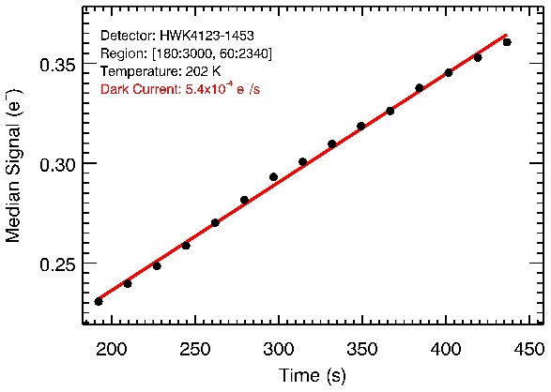 | 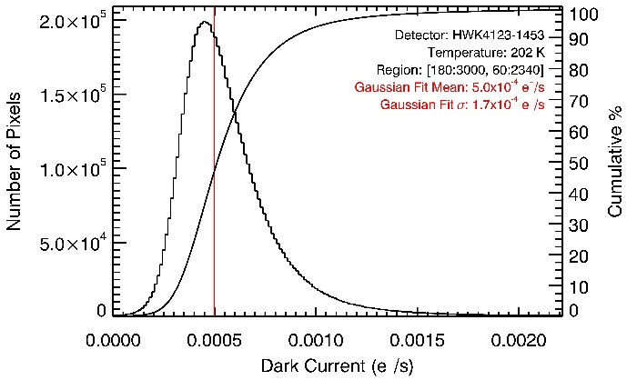
Figure 1. (left) The plot shows the median dark signal as a function of time at 202 K. The black points are the median dark signal of all pixels in the analysis region. The red line is a fit to the signal as a function of time. The slope of the red line is the DC of 0.00054 e⁻/s/pixel. (right) The plot shows the histogram of DC per pixel at 202 K. The y-axis on the left is the number of pixels per DC bin on the x-axis. The y-axis on the right is the cumulative percentage of pixels up to a DC bin. The vertical red line is the mean of a Gaussian fit to the distribution, which has a DC value of 0.0005 e⁻/s/pixel.
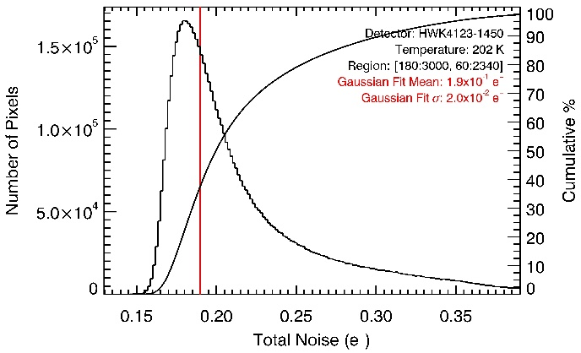
Figure 2. The plot shows the total noise histogram. The y-axis on the left is the number of pixels per total noise bin on the x-axis. The y-axis on the right is the cumulative percentage of pixels up to a total noise bin. The red line is the mean of a Gaussian fit to the distribution, which gives a read noise of 0.19 e⁻/pixel.
  - Read Noise
The total noise distribution is shown in Figure 2. Read noise dominates the total noise when the DC shot noise is negligible. The histogram in Figure 2 shows the RN distribution using the standard deviation of the signal in each pixel at a temperature of 202 K. The smooth black curve shows the cumulative percentage of pixels up to a given read noise bin. The red line is the mean value of a Gaussian fit to the distribution, giving an RN of 0.19 e⁻/pixel. The distribution has a hot tail typical of CMOS SPCDs [3] [4].
  - Conversion Gain and FD Capacitance
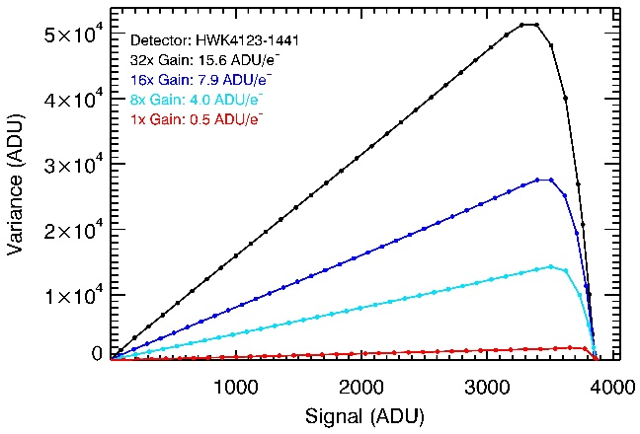
Figure 3. The plot shows PTCs for all programmable gains. The y-axis is the variance in signal in ADU. The x-axis is the signal in ADU. The inverse slope of the linear region is CG_{sys}.
We measure CG_{sys} using the PTE to get the inverse slope of a fit to the linear region of the PTC. Figure 3 shows PTCs for all programmable gains of the HWK4123. The black curve is 32× gain, the dark blue curve is 16× gain, the light blue curve is 8× gain, and the red curve is 1× gain. Each dot in the curves represents the median dark-subtracted signal for all pixels in the analysis region. The PTCs show that the detector output value reaches the maximum of the ADC sampling range (4,095 ADU), which is limited by the voltage swing at the FD and does not reach physical saturation [5]. Note that the x-axis in Figure 3 shows the dark-subtracted signals. We divide 4,095 ADU by CG_{sys} to obtain the number of electrons at the maximum output value, listed as N_{elec} in Table 1. The team is investigating methods to measure physical saturation at all gains by changing the voltage level at TG.
We then measure CG_{measured} and multiply by CG_{sys} to calculate CG_{FD} using Error! Reference source not found. and ε_{coupling} = 0.94. We derive CG_{elec} using Error! Reference source not found., CG_{measured}, ε_{coupling} = 0.94, and G_{SF} = 0.9. We calculate C_{FD} using Error! Reference source not found. and CG_{FD}. Table 1 compiles measurements of CG_{sys} and CG_{measured}, and derived values for CG_{elec}, CG_{FD}, C_{FD}, and N_{elec} for all programmable gains of the HWK4123.
 | CG_{sys} [ADU/e⁻] | CG_{measured} [μV/ADU] | CG_{elec}  [μV/ADU] | CG_{measured} ×CG_{sys}[μV/e⁻] | CG_{FD}  [μV/e⁻] | C_{FD}  [fF] | N_{elec}  [e⁻]
Gain: 32× | 15.6 | 11.6 | 9.8 | 181.2 | 170.3 | 0.94 | ~256
Gain: 16× | 7.9 | 22.8 | 19.3 | 180.5 | 169.7 | 0.94 | ~504
Gain: 8× | 4.0 | 45.6 | 38.6 | 180.6 | 169.8 | 0.94 | ~1,010
Gain: 1× | 0.5 | 361.1 | 305.5 | 180.6 | 169.8 | 0.94 | ~8,000
Table 1. This table lists measurements for CG_{sys} and CG_{measured}, and derived values for CG_{measured} × CG_{sys}, CG_{elec}, CG_{FD}, C_{FD}, and N_{elec}, for all programmable gains of the HWK4123.
  - Quantum Efficiency
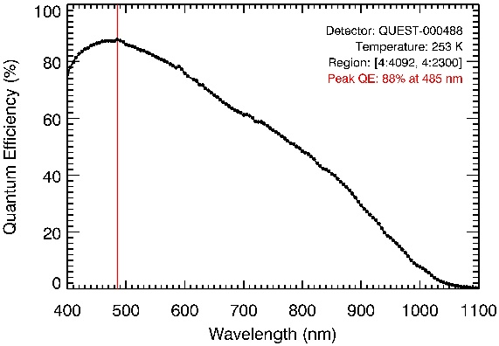
Figure 4. The curve shows the HWK4123 QE measured at 253 K with the QUEST system. The red line marks the peak QE of 88% at 485 nm.
The QE shown in Figure 4 is measured with the QUEST system. The peak QE is 88% at 485 nm as shown by the red line. In addition, QE is above 80% from 410 nm to 570 nm. The central wavelengths of the measurements have a spacing of 5 nm. Each black dot in Figure 4 represents the median value of the QE of all pixels in the analysis region, at 253 K. At wavelengths shorter than 400 nm, the probability of producing more than one electron increases (QY greater than unity). The team is actively investigating QY corrections to QE below 400 nm by following the work of [6].
  - Crosstalk
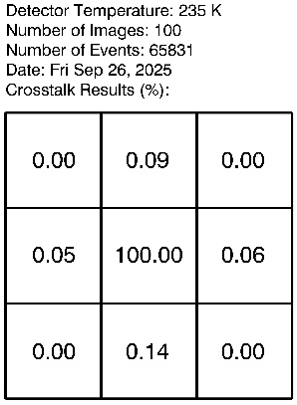
Figure 5. The panel shows the crosstalk for the HWK4123.
We measure crosstalk using the ratio of the signal in pixels surrounding a central pixel affected by an HEE. Figure 5 shows the mean value of these ratios for ~66,000 events, with the central pixel normalized to 100%. Crosstalk is negligible for the HWK4123 when compared to dominant noise terms under assumed observing conditions (i.e., dark current, read noise, zodiacal and exozodiacal dust), and will not be a concern for a flagship mission such as HWO.
  - Persistence
We measure persistence as the residual signal in a pixel following a reset. We use a pulsed laser attached to the QUEST camera to illuminate the HWK4123 to an initial fluence of ~5100 e⁻, which is ~70% of the maximum signal measurable with the QUEST camera using dual-gain mode operation. After 0.5 s, only 0.02% of the initial signal remains (~1 e⁻) in the first dark frame after the pulse. This level of persistence is negligible, especially when considering that target slews in space observatories (such as HWO) provide ample time to continuously read out and clear the pixels, such that persistence will not limit observations.
  - Simulated Observation of an Earth-like Exoplanet
This section describes the impact of detector performance on the SNR of an idealized low-flux exoplanet observation. Following the work of Refs. 45–47, we estimate the integrated photon flux per spectral channel for modern Earth, shown in Fig. 15. We use a 6-m diameter telescope and an end-to-end throughput of 27%.48 On Earth, the presence of O2 is due to a biological process: photosynthesis. Although other life-bearing eons of Earth lacked detectable O2, it reveals the presence of our modern biosphere and may do so for other exoplanets, with a careful treatment of false positives.46,49–54 As such, we select the O2-A band at 760 nm as the target biosignature and obtain ∼8 photons per hour from the line center. We calculate SNR as a function of time for a single pixel. As the HWO design is not finalized, we use the simulation above to justify a photon arrival rate of ∼1 photon per hour per pixel to decouple the SNR calculation from unknowns. This analysis ignores contaminating sources of photons (zodiacal and exozodiacal dust, coronagraph speckles, scattered starlight) to focus on the impact of detector performance on SNR when observing at a rate of one photon per hour. Table 5 describes the quantities used to calculate SNR in Eq. (9). We assume an integration time of 250 s per frame to limit the effects of cosmic rays to ∼1% of the pixel array. HWO will orbit at the Sun-Earth Lagrange Point 2 (L2), where JWST measurements show a shielded cosmic ray event rate of ∼2.3 ions∕cm2∕s near solar maximum.55 A typical event affects 7.1 pixels in JWST’s 18 μm-pitch H2RG detectors, which scales by area to ∼100 HWK4123 pixels. The HWK4123 has an active area of ∼2cm2, implying ∼1150 cos mic ray events in a 250 s exposure and contamination of ∼1% of its 9.4 Mpixels. We calculate the number of frames (n) by dividing the total integration time (t) by 250 s and use a step size of 250 s to avoid fractional frames.
Figure 15 shows the SNR for a single pixel observing one photon per hour under multiple detec tor assumptions. The first two curves correspond to a perfect detector (solid light blue) and a detector with HWO’s specifications from Table 6 (dashed dark blue). The perfect detector, with zero RN, zero DC, and 100% QE, reaches SNR ¼ 5 in 1.04 days, whereas the HWO detector requires 1.81 days. The remaining three curves correspond to the HWK4123 detector with its measured DC and QE performance, using three different treatments of RN: the measured RN performance (black dotted), zero RN (gold dashed), and a BER rounding step (red double dot). We use the BER rounding step to exploit an advantage of SPCDs by treating the reported digital value as the outcome of a Bernoulli trial. As RNdecreases, the BER drops rapidly (Fig. 6), increasing the probability that the reported floating-point value lies closest to the correct integer number of electrons. Rounding to the near est integer changes the variance of the signal estimator from analog read noise to the variance of a Bernoulli trial. This variance is p · ð1 − pÞ, where p is the probability of success, and (1 − p)is the probability of failure (i.e., the BER). Consequently, we can rewrite the variance as p · ðBERÞ, and as 1 −p ¼ BER,wesubstitute pwith 1− BERto get ð1− BERÞ · ðBERÞ. We can replace the RN2 term in Eq. (9) with ð1 − BERÞ · ðBERÞ, or simply BER as the first term is approx imately 1 for small BER. Using this treatment, the rounding-step HWK4123 case reaches SNR ¼ 5 in 8.20 days, approaching the 8.09 days for the zero RN HWK4123 case, and improving upon the 9.88 days required for the regular HWK4123 performance. The BER rounding step does not eliminate the detector’s analog RN but instead takes advantage of a concept similar to the binary symmetric channel in telecommunications to significantly reduce noise. Even so, current CMOS SPCDs require longer integration times than the HWO target detector, reducing the total number of observations possible for a fixed mission lifetime.

Symbol | Quantity Description | Units | Notes
S_{P} | Signal from exoplanet | γ/s/channel | from Eq. 2
S_{ZD} | Signal from zodiacal dust | γ/s/channel | from Eq. 2
S_{XZD} | Signal from exozodiacal dust | γ/s/channel | from Eq. 2
S_{S} | Signal from host star | γ/s/channel | from Eq. 2
K_{CR} | Coronagraph contrast ratio | dimensionless | following [10]
QE | Detector quantum efficiency | e⁻/γ | from Section 3.4
DC | Detector dark current | e⁻/s/pixel | from Section 3.1
RN | Detector read noise | e⁻/pixel | from Section 3.2
p | Number of pixels | pixel | following [11]
n | Number of frames | dimensionless | n = t / 250 s
t | Total integration time | s | step size = 250 s
Table 2. This table lists the quantities used to determine SNR in Eq. 3.

 | $$SNR\left(t,n\right)= \frac{S_{P}⋅t ⋅QE}{\sqrt{({ (S}_{P}+S_{ZD}+S_{XZD}+S_{S}⋅K_{CR})⋅QE+DC)⋅t+{(RN⋅\sqrt{n})}^{2}} }$$ | Eq. 3

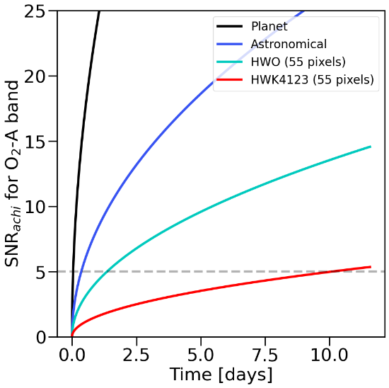 | 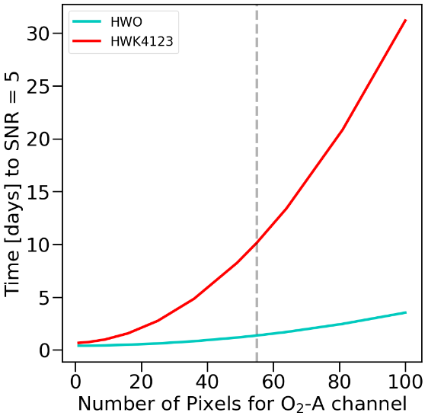
Figure 7 (a) Integrated spectrum of modern Earth with the O3,O2,H2O, and vegetation red edge (VRE) biosignatures. The y-axis is the number of photons per second per spectral channel on the x-axis. (b) SNR as a function of time for different detector assumptions.
- Work that Remains
  - Understanding Low Signal Nonlinearity (LSNL)
While low signal nonlinearity is clearly observed, what is causing it? Is it canonical traps that are defects in the material? Is it unintended secondary potential wells that form during charge transfer, during transfer gate operation, or some other time? Where is this effect located, and can we figure that out? Is the effect dependent on temperature, wavelength, or programmable gain setting? How can we tell this apart from quantum efficiency and quantum yield, since these quantities also effect the translation from “number of photons that arrive at the sensor” to “number of electrons reported in the FITS file?”
  - Understanding the Dark Current Plateau and Glow (Multiplexer and Unit Cell)
Not much is known about the dark current plateau for silicon sensors. Are we hitting a physical limit of the material? Is the system in which the sensor finds itself too bright in the optical? Is the multiplexer glow enough to cause the dark current plateau for the entire sensor? Can there be unit cell glow at play? Under what circumstances would MOSFETs used in SPSCMOS emit light? Do we meet these conditions? Can we break the dark current plateau, since the lowest dark current we can measure is only as low as the system is dark?
  - Leveraging Single-Photon Counting to Introduce Rounding Step Using Bit Error Rate to Improve SNR
Because we have single-photon counting detectors, the device will report a floating point number of electrons. However, because the read noise is low, the bit error rate is also low. As such, we can assign the floating point number of electrons with a degree of certainty (the bit error rate) to integer electron numbers. In doing so, the uncertainty associated with the measurement is no longer the analog read noise, but it is the error of a Bernoulli trial: either we assigned the correct integer number of electrons, or we did not, and the “likelihood of failure” is equal to the bit error rate. As such, we are developing and investigating the validity of this processing method of information, which may provide a software boost to a technological limit and circumvent the need for R&D by using intelligent signal processing.

- Conclusion
The Habitable Worlds Observatory will need improved detector technology to achieve its science goals. CMOS SPCDs satisfy some of the detector specifications for read noise, dark current, and quantum efficiency. Specifically, the HWK4123 is a photon-number-resolving detector with a dark current of 0.0005 e⁻/s/pixel, a read noise of 0.19 e⁻/pixel, a quantum efficiency above 80%, and negligible persistence and crosstalk. These results indicate that CMOS SPCDs represent a credible and technologically mature pathway toward development for HWO. Part of that development includes the completion of our ongoing on-sky testing program at a telescope, and radiation testing for an equivalent irradiation dose at L2, where HWO would orbit. As such, the continued development of CMOS SPCDs offers a clear path to reducing detector risk for future HWO instruments.

Disclosures
The authors declare that there are no financial interests, commercial affiliations, or other potential conflicts of interest that could have influenced the objectivity of this research or the writing of this paper.

Code and Data Availability
Data reported in this paper will be free for reuse. The Flexible Image Transport System (FITS) data contain significant intellectual property and will only be shared in response to requests that do not jeopardize confidentiality.

Acknowledgments
The results presented in this paper are supported by the NASA Strategic Astrophysics Technology (SAT) Program (Grant No. 80NSSC20K0310). The large language model ChatGPT was used for language and grammar clean-up.

References

[1] | S. Xie and A. Theuwissen, "Compensation for Process and Temperature Dependency in a CMOS Image Sensor," Sensors, vol. 19, no. 4, 2019.
[2] | Y. Chen, A. J. Mierop and A. J. P. Theuwissen, "A CMOS Image Sensor With In-Pixel Buried-Channel Source Follower and Optimized Row Selector," IEEE Transactions on Electron Devices, vol. 56, no. 11, pp. 2390-2397, 2009.
[3] | J. Gallagher, L. Buntic, E. Alexani, K. Bouthsarath and D. Figer, "Characterizing radiation-tolerant single photon resolving CMOS detectors," Proceedings of the SPIE, vol. 13103, 2024.
[4] | J. P. Gallagher, L. Buntic, W. Deng and D. F. Figer, "Characterization of single-photon sensing and photon-number resolving CMOS image sensors," SPIE Astronomical Telescopes + Instrumentation, vol. 12191, 2022.
[5] | K. Cho and B. Johnson, "0.5e- rms Read Noise CMOS Image Sensors and Sub-Electron Image Processing for Night Vision Application," International Image Sensor Workshop, 2023.
[6] | S. Baggett, "WFC3 TV3 Testing: Quantum Yield in the UV," WFC3 Instrument Science Report, 2008.
[7] | C. C. Stark, "ExoVista: A Suite of Planetary System Models for Exoplanet Studies," The Astronomical Journal, vol. 163, no. 3, p. 11, 2022.
[8] | "LUVOIR Final Report," 26 August 2019. [Online]. Available: https://asd.gsfc.nasa.gov/luvoir/reports/LUVOIR_FinalReport_2019-08-26.pdf.
[9] | L. Pueyo, C. Stark, R. Juanola-Parramon, N. Zimmerman, M. Bolcar, A. Roberge, G. Arney, G. Ruane, A. J. Riggs, R. Belikov, D. Sirbu, D. Redding, R. Soummer, I. Laginja and S. Will, "The LUVOIR Extreme Coronagraph for Living Planetary Systems (ECLIPS) I: searching and characterizing exoplanetary gems," in Proceedings of SPIE, 2019, 2019.
[10] | M. R. Bolcar, F. Zhao and P. Scowen, "Habitable Worlds Observatory Technology Roadmap," 14 11 2024. [Online]. Available: https://ntrs.nasa.gov/api/citations/20240014305/downloads/Bolcar_MirrorTechDays_HWOTech_20241118_v3.pdf.
[11] | C. C. Stark, N. Latouf, A. M. Mandell and A. Young, "Optimized bandpasses for the Habitable Worlds Observatory’s exoEarth survey," Journal of Astronomical Telescopes, Instruments, and Systems, vol. 10, no. 1, 2024.
[12] | B. J. Rauscher and D. Fixsen, "JWST NIRSpec's Cosmic Ray Experience at L2," Publications of the Astronomical Society of the Pacific, vol. 137, no. 9, p. 095003, 2025.
[13] | T. D. Brandt and D. S. Spiegel, "Prospects for Detecting Oxygen, Water, and Chlorophyll on an Exo-Earth," PNAS, vol. 111, p. 11, 2014.
[14] | M. Damiano and R. Hu, "Reflected Spectroscopy of small exoplanets II: characterization of terrestrial exoplanets," The Astronomical Journal, vol. 163, p. 14, 2022.
[15] | S. Seager and D. Deming, "Exoplanet Atmospheres," Annual Review of Astronomy and Astrophysics, vol. 48, pp. 631-672, 2010.
[16] | E. Schwieterman, N. Kiang, M. Parenteau, C. Harman, S. DasSarma, T. Fisher, G. Arney, H. Hartnett, C. Reinhard, S. Olson, V. Meadows, C. Cockell, S. Walker, J. Grenfell, S. Hedge, S. Rugheimer, R. Hu and T. Lyons, "Exoplanet Biosignatures: A Review of Remotely Detectable Signs of Life," Astrobiology, vol. 18, no. 6, p. 46, 2018.
[17] | K. Y. Feng, T. D. Robinson, J. J. Fortney, R. E. Lupu, M. S. Marley, N. K. Lewis, B. Macintosh and M. R. Line, "Characterizing Earth Analogs in Reflected Light: Atmopsheric Retrieval Studies for Future Space Telescopes," The Astronomical Journal, vol. 155, no. 5, p. 24, 2018.
[18] | V. S. Meadows, C. T. Reinhard, G. N. Arney, M. N. Parenteau, E. W. Schwieterman, S. D. Domagal-Goldman, A. P. Lincowski, K. R. Stapelfeldt, H. Rauer, S. DasSarma, S. Hedge and e. a. Narita, "Exoplanet Biosignatures: Understanding Oxygen as a Biosignature in the Context of Its Environment," Astrobiology, vol. 18, no. 6, pp. 630-662, 2018.
[19] | J. T. O'Malley-James and L. Kaltenegger, "The Vegetation Red Edge Biosignature Through Time on Earth and Exoplanets," Astrobiology, vol. 18, no. 9, pp. 1123-1136, 2018.
[20] | E. Alexani, "Simulation of a Single Photon Counting Photonic Spectrograph for Direct Imaging of Exoplanet Atmospheres with the Habitable Worlds Observatory," ProQuest, p. 126, 2024.
[21] | M. A. Quijada, L. Rodriguez de Marcos, J. del Hoyo and E. Wollack, "Advanced Al Mirrors Protected with LiF Overcoat to Realize Stable Mirror Coatings for Astronomical Telescopes," 8 May 2023. [Online]. Available: https://ntrs.nasa.gov/api/citations/20230006299/downloads/mquijada_SVC-Talk_2023_Rev1.pdf.
[22] | Thorlabs, "Longpass Dichroic Mirrors/Beamsplitters," 4 February 2019. [Online]. Available: https://media.thorlabs.com/contentassets/54b880c965d44c29973cc893d59dba74/dmlp425.xlsx.
[23] | Thorlabs, "Longpass Dichroic Mirrors/Beamsplitters," 4 February 2019. [Online]. Available: https://media.thorlabs.com/contentassets/c549d43f47dd4caf8187196a92598d63/dmlp900.xlsx.
[24] | P.-K. Chiu, D. Chiang, C.-T. Lee, Y.-W. Lin and C.-N. Hsiao, "Optical properties and crystallinity of silver mirrors under a 35 krad cobalt-60 radiation," Journal of Vacuum Science & Technology A, vol. 33, no. 5, p. 05E104, 2015.
[25] | A. Eldorado Riggs, V. Bailey, D. C. Moody, E. Sidick, K. Balasubramanian, D. E. Moore, D. W. Wilson, G. Ruane, D. Sirbu, J. Gersh-Range, J. Trauger, B. Mennesson and N. Siegler, "Flight mask designs of the Roman Space Telescope coronagraph instrument," in SPIE Optical Engineering + Applications, San Diego, 2021.
[26] | E. H. Por, "Phase-apodized-pupil Lyot Coronagraphs for Arbitrary Telescope Pupils," The Astrophysical Journal, vol. 888, no. 2, p. 127, 2020.
[27] | Abrisa Technologies, "Broadband Coatings," 2015. [Online]. Available: https://abrisatechnologies.com/optical-coatings/broadband/.
[28] | P. Saxena, M. J. Rizzo, C. Mejia Prada, J. Llop Sayson, Q. Gong, E. J. Cady, A. M. Mandell, T. D. Groff and M. W. McElwain, "Commissioning and performance results of the WFIRST/PISCES integral field spectrograph," in SPIE Optical Engineering + Applications, San Diego, 2017.
[29] | Hamamatsu Photonics K.K., "ORCA®-Quest qCMOS® camera C15550-20UP Technical note," May 2022. [Online]. Available: https://camera.hamamatsu.com/content/dam/hamamatsu-photonics/sites/documents/99_SALES_LIBRARY/sys/SCAS0154E_C15550-20UP_tec.pdf.
[30] | E. Alexani, D. Figer and P. Gatkine, "Simulation of a single photon counting photonic spectrograph for exoplanet atmospheric characterization," in Proceedings of the SPIE, Yokohama, 2024.
[31] | P. O'Connor, V. Radeka, D. Figer, J. Geary, D. Gilmore, J. Oliver, C. Stubbs, P. Takacs and J. Tyson, "Study of silicon sensor thickness optimization for LSST," SPIE Astronomical Telescopes + Instrumentation, vol. 6276, 2006.
[32] | J. P. Gallagher, "Characterization of Single Photon Sensing and Photon Number Resolving CMOS Detectors for Astrophysics," ProQuest LLC., Rochester, 2020.
[33] | J. P. Gallagher, L. Buntic, W. Deng, E. R. Fossum and D. F. Figer, "Radiation tolerance of a single-photon counting complementary metal-oxide semiconductor image sensor," JATIS, 2024.
[34] | M. Hoenk, T. Jones, M. Dickie, F. Greer, T. Cunningham, E. Blazejewski and S. Nikzad, "Delta-doped back-illuminated CMOS imaging arrays: progress and prospects," SPIE Photonic Devices + Applications, vol. 7419, 2009.
[35] | "Pathways to Discovery in Astronomy and Astrophysics for the 2020s," National Academies Press, Washington, 2021.
[36] | L. D. Feinberg and B. Mennesson, "Exploratory Analytic Cases and Coronagraph Exploratory Cases," 3 June 2025. [Online]. Available: https://ntrs.nasa.gov/api/citations/20240006492/downloads/Exploratory%20and%20Analytic%20Cases%20HWO.pdf.
[37] | E. R. Fossum, J. Ma and S. Masoodian, "Quanta image sensor: concepts and progress," in Proceedings of SPIE, 2016.
[38] | R. G. Kovacs, "Investigation of Supporting Hardware and Pixel Design for Photon-Number-Resolving Imagers," 2021. [Online]. Available: https://ridl.cfd.rit.edu/products/theses%20and%20senior%20projects/Reid%20Kovacs%20MS%20GradPaper.pdf.
[39] | S. Nikzad, M. E. Hoenk, F. Greer, B. Jacquot, S. Monacos, T. J. Jones, J. Blacksberg, E. Hamden, D. Schiminovich, C. Martin and P. Morissey, "Delta-doped electron-multiplied CCD with absolute quantum efficiency over 50% in the near to far ultraviolet range for single photon counting applications," Optica Applied Optics, vol. 51, no. 3, pp. 365-369, 2012.
[40] | M. E. Hoenk, A. D. Jewell, G. Kyne, J. Hennessy, T. Jones, S. Cheng, S. Nikzad, D. Morris, K. Lawrie and J. Skottfelt, "2D-doped silicon detectors for UV/optical/NIR and x-ray astronomy," in Proceedings of SPIE, 2022.
[41] | J. Ma, S. Chan and E. R. Fossum, "Review of Quanta Image Sensors for Ultralow-Light Imaging," IEEE Transactions on Electron Devices, vol. 69, no. 6, pp. 2824-2839, 2022.
[42] | M. R. Bolcar, F. Zhao, P. Scowen and e. al., "Habitable Worlds Observatory Technology Development Plan," 29 July 2025. [Online]. Available: https://ntrs.nasa.gov/api/citations/20250007159/downloads/Bolcar_HWOTechRoadmaps_HWO25_20250729_v3.pdf?attachment=true.
[43] | W. Deng, D. Starkey, J. Ma and E. R. Fossum, "Modelling Measured 1/f Noise in Quanta Image Sensors (QIS)," International Image Sensor Society - 2019 Workshop IISW, 2019.
[44] | J. Ma, D. Starkey, A. Rao, K. Odame and E. R. Fossum, "Characterization of Quanta Image Sensor Pump-Gate Jots With Deep Sub-Electron Read Noise," Journal of the Electron Devices Society, vol. 3, no. 6, pp. 472 - 480, 2015.
[45] | Fairchild Imaging, "HWK4123 Product Brief," August 2025. [Online]. Available: https://fairchildimaging.com/hubfs/Product%20Briefs/MAN%200244_HWK4123_Rev%20A.pdf.
[46] | Hamamatsu Photonics K.K., "ORCA-Quest 2 qCMOS camera C15550-22UP," June 2025. [Online]. Available: https://www.hamamatsu.com/content/dam/hamamatsu-photonics/sites/documents/99_SALES_LIBRARY/sys/SCAS0166E_C15550-22UP.pdf.
[47] | Hamamatsu Photonics K.K., "ORCA-Quest IQ qCMOS camera C15550-23UP," August 2025. [Online]. Available: https://camera.hamamatsu.com/content/dam/hamamatsu-photonics/sites/documents/99_SALES_LIBRARY/sys/SCAS0179E_C15550-23UP.pdf.
[48] | J. Ma, D. Zhang, D. Robledo, L. Anzagira and S. Masoodian, "Ultra-high-resolution quanta image sensor with reliable photon-number-resolving and high dynamic range capabilities," Scientific Reports, vol. 12, 2022.
[49] | L. K. Harding, R. Demers, M. E. Hoenk, P. Peddada, B. Nemati, M. Cherng, D. Michaels, L. S. Neat, A. Loc, N. L. Bush, D. J. Hall, N. J. Murray, J. P. D. Gow, R. Burgon, A. D. Holland and A. L. Reinher, "Technology advancement of the CCD201-20 EMCCD for the WFIRST coronagraph instrument: sensor characterization and radiation damage," Journal of Astronomical Telescopes, Instruments, and Systems, vol. 2, no. 1, p. 011007, 2015.
[50] | J. Crass, A. Bechter, B. Sands, D. King, R. Ketterer, M. Engstrom, R. Hamper, D. Kopon, J. Smous, J. Crepp, M. Montoya, O. Durney, D. Cavalieri, R. Reynolds, M. Vansickle, E. Onuma, J. Thomes, S. Mullin, C. Shelton and e. al., "Final design and on-sky testing of the iLocater SX acquisition camera: broad-band single-mode fibre coupling," Monthly Notices of the Royal Astronomical Society, vol. 501, p. 18, 2021.
[51] | N. Jovanovic, N. Cvetojevic, B. Norris, C. Betters, C. Schwab, J. Lozi, O. Guyon, S. Gross, F. Martinache, P. Tuthill, D. Doughty, Y. Minowa, N. Takato and J. Lawrence, "Demonstration of an efficient, photonic-based astronomical spectrograph on an 8-m telescope," Optics Express, pp. 17753-17766, 2017.
[52] | B. Norris and J. Bland-Hawthorn, "Astrophotonics: The Rise of Astrophotonics in Astronomy," Optics and Photonics News, vol. 30, no. 5, p. 26, 2019.
[53] | A. Desmet, A. Radosavljevic, J. Missinne, D. van Thourhout and G. van Steenberge, "Laser Written Glass Interposer for Fiber Coupling to Silicon Photonic Integrated Circuits," IEEE Photonics Journal, vol. 13, p. 13, 2021.
[54] | A. Li, C. Yao, J. Xia, H. Wang, Q. Cheng, R. Penty, Y. Fainman and S. Pan, "Advances in cost-effective integrated spectrometers," Light: Science & Applications, vol. 11, 2022.
[55] | N. R. Shade, G. Kyne, S. Nikzad, E. Charbon and E. R. Fossum, "Characterization and validation of next generation image sensors for space applications," in SPIE Astronomical Telescopes + Instrumentation, Yokohama, Japan, 2024.
[56] | B. Hanold, D. Figer, J. Lee, K. Kolb, I. Marcuson, E. Corrales, J. Getty and L. Mears, "Large format MBE HgCdTe on silicon detector development for astronomy," SPIE, p. 96090Y, 2015.
[57] | J. R. Janesick, Photon Transfer: DN → λ, Bellingham, WA: SPIE Press, 2007.
[58] | L. Barak, I. M. Bloch, A. Botti, M. Cababie, G. Cancelo, L. Chaplinsky, F. Chierchie, M. Crisler, A. Drlica-Wagner, R. Essig, J. Estrada, E. Etzion, G. Fernandez Moroni and D. Gift, "SENSEI: Characterization of Single-Electron Events Using a Skipper Charge-Coupled Device," Physical Review Applied, vol. 17, no. 1, p. 014022, 2022.
[59] | E. Marrufo Villalpando, A. Drlica-Wagner, A. A. Plazas Malagon, A. Bakshi, M. Bonati, J. Campa, B. Cancino, C. R. Chavez, J. Estrada, G. Fernandez Moroni, L. Fraga, M. E. Gaido and S. Holland, "Characterization and Optimization of Skipper CCDs for the SOAR Integral Field Spectrograph," Publications of the Astronomical Society of the Pacific, vol. 136, no. 4, p. 045001, 2024.
[60] | Nüvü Cameras, "nuvucameras_hnu512v3.4," 03 June 2025. [Online]. Available: https://www.nuvucameras.com/wp-content/uploads/nuvucameras_hnu512v3.4.6.pdf.
[61] | Fairchild Imaging Systems, "HWK1411_NOV2024_VF.pdf," 25 Novemeber 2024. [Online]. Available: https://fairchildimaging.com/hubfs/Product%20Briefs/HWK1411_NOV2024_VF.pdf.
[62] | J. Ma, D. Zhang, O. Elgendy and S. Masoodian, "A Photon-Counting 4Mpixel Stacked BSI Quanta Image Sensor with 0.3e- Read Noise and 100dB Single-Exposure Dynamic Range," in 2021 Symposium on VLSI Circuits, Kyoto, 2021.
[63] | Teledyne e2v, "CCD201-20 BSI Datasheet (v11).pdf," 22 05 2025. [Online]. Available: https://www.teledynespaceimaging.com/en-us/Products_/Documents/ccd-datasheets/CCD201-20%20BSI%20Datasheet%20(v11).pdf.
[64] | Teledyne e2v, "CCD97-00 BSI Datasheet (v10).pdf," 21 05 2025. [Online]. Available: https://www.teledynespaceimaging.com/en-us/Products_/Documents/ccd-datasheets/CCD97-00%20BSI%20Datasheet%20(v10).pdf.
[65] | G. Fernández Moroni, J. Estrada, G. Cancelo, S. E. Holland, E. E. Paolini and H. T. Diehl, "Sub-electron readout noise in a Skipper CCD fabricated on high resistivity silicon," Experimental Astronomy, vol. 34, pp. 43-64, 2012.
[66] | J. Ma, S. Masoodian, D. A. Starkey and E. R. Fossum, "Photon-Number-Resolving Megapixel Image Sensor at Room Temperature without Avalanche Gain," Optica, vol. 4, no. 12, pp. 1474-1481, 2017.
[67] | E. R. Fossum, J. Ma, S. Masoodian, L. Anzagira and R. Zizza, "The Quanta Image Sensor: Every Photon Counts," Sensors, vol. 16, no. 8, 2016.
[68] | G. R. Hopkinson, A. Mohammadzadeh and R. Harboe-Sorensen, "Radiation effects on a radiation-tolerant CMOS active pixel sensor," IEEE Transactions on Nuclear Science, vol. 51, no. 5, pp. 2753-2762, 2004.
[69] | J. P. D. Gow, N. J. Murray, A. D. Holland, D. J. Hall, M. Cropper, D. Burt, G. Hopkinson and L. Duvet, "Assessment of space proton radiation-induced charge transfer inefficiency in the CCD204 for the Euclid space observatory," Journal of Instrumentation, vol. 7, no. 1, 2012.
[70] | G. Hopkinson, D. Purll, A. Abbey, A. Short, D. Watson and A. Wells, "Active pixel array devices in space missions," Nuclear Instruments and Methods in Physics Research Section A: Accelerators, Spectrometers, Detectors and Associated Equipment, vol. 513, no. 1, pp. 327-331, 2003.
[71] | R. Massey, "Charge Transfer Inefficiency in the Hubble Space Telescope since Servicing Mission 4," Monthly Notices of teh Royal Astronomical Society, vol. 409, no. 1, pp. L109-L113, 2010.
[72] | J. Anderson and J. E. & Ryon, "Improving the Pixel-Based CTE-correction Model for ACS/WFC," Instrument Science Report ACS 2018-04, 2018.
[73] | R. Massey, C. Stoughton, A. Leauthaud, J. Rhodes, A. Koekemoer, R. Ellis and E. Shaghoulian, "Pixel-based correction for Charge Transfer Inefficiency in the Hubble Space Telescope Advanced Camera for Surveys," Monthly Notices of the Royal Astronomical Society, vol. 401, no. 1, pp. 371-384, 2009.
[74] | Y. Chen, X. Wang, A. J. Mierop and A. J. P. Theuwissen, "A CMOS Image Sensor With In-Pixel Buried-Channel Source Follower and Optimized Row Selector," IEEE Transactions on Electron Devices, vol. 56, no. 11, pp. 2390-2397, 2009.
[75] | S. Chen, J. Ma, D. B. Hondongwa and E. R. Fossum, "High Conversion-Gain Pinned-Photodiode Pump-Gate Pixels in 180-nm CMOS Process," IEEE Journal of the Electron Devices Society, vol. 5, no. 6, pp. 509-517, 2017.
[76] | K. D. Stefanov, M. J. Prest, M. Downing, E. George, N. Bezawada and A. D. Holland, "Simulations and Design of a Single-Photon CMOS Imaging Pixel Using Multiple Non-Destructive Signal Sampling," Sensors, vol. 20, no. 7, 2020.
[77] | S. Sim and J. Jun, "Advancements in Active-Pixel-Type CMOS Image Sensor Design Techniques and Architectures for Wide Dynamic Range," Sensors, vol. 26, no. 2, 2026.
[78] | C. Park, I. Park, W. Jo, J. Cheon and Y. Chae, "A 75.6μVrms Read Noise CMOS Image Sensor with Pixel Noise Reduction Using Noise-Coupled Amplifiers," International Image Sensors Society, 2017.
[79] | E. R. Fossum, "The Invention of CMOS Image Sensors: a Camera in Every Pocket," 2020 Pan Pacific Microelectronics Symposium, pp. 1-6, 2020.
[80] | F. Zhang and H. Niu, "A 75-ps Gated CMOS Image Sensor with Low Parasitic Light Sensitivity," Sensors, vol. 16, no. 7, 2016.
[81] | C. Layden, K. Burdge, G. Furesz, J. Garcia-Mejia, J. Dinsmore, G. Mo, D. Osip, J. J. Piotrowski, R. W. Romani, A. Berne, D. Chakrabarty and E. Chickles, "proto-Lightspeed: a high-speed, ultra-low read noise imager on the Magellan Clay Telescope," arXiv e-prints, 2026.
[82] | J. Vallerga, O. H. W. Siegmund, A. Tremsin and J. McPhate, "Current and future capabilities of MCP detectors for UV-Vis instruments," September 2011. [Online]. Available: https://assets.science.nasa.gov/content/dam/science/astro/programs/cosmic-origins/events/2011/stsci_sept2011/Vallerga_COPAG2011.pdf.
[83] | N. V. Loukianova, H. O. Folkerts, J. P. V. Maas, D. W. E. Verbugt, A. J. Mierop, W. Hoekstra and E. Roks, "Leakage Current Modeling of Test Structures for Characterization of Dark Current in CMOS Image Sensors," IEEE Transactions on Electron Devices, vol. 50, no. 1, pp. 77 - 83, 2003.
[84] | D. McGrath, S. Tobin, V. Goiffon, P. Magnan and A. Le Roch, "Dark Current Limiting Mechanisms in CMOS Image Sensors," Electronic Imaging, vol. 30, no. 11, pp. 354-1 354-8, 2018.
[85] | E. R. Fossum and D. B. Hondongwa, "A Review of the Pinned Photodiode for CCD and CMOS Image Sensors," IEEE Journal of the Electron Devices Society, vol. 2, no. 3, pp. 33 - 43, 2014.
[86] | J. Ma and E. R. Fossum, "A pump-gate jot device with high conversion gain for a quanta image sensor," IEEE J. Electron Devices Soc., vol. 3, no. 2, pp. 73 - 77, 2015.
[87] | L. Werner, U. Linke, I. Müller, T. Kubarsepp, M.-M. Sildoja, T. Tran and J. Gran, "Quantum yield in induced-junction silicon photodiodes at wavelengths around 400 nm," Metrologia, vol. 61, no. 3, 2024.
[88] | E. Fossum, "Photon Counting Error Rates in Single-Bit and Multi-Bit Quanta Image Sensors," IEEE Journal of the Electron Devices Society, 2016.
[89] | E. R. Fossum, "Moedling the Performance of Single-Bit and Multi-Bit Quanta Image Sensors," Journal of the Electron Devices Society, vol. 1, no. 9, pp. 166 - 174, 2013.
[90] | D. F. Figer, B. J. Rauscher, M. W. Regan, E. Morse, J. Balleza, L. Bergeron and H. S. Stockman, "Independent testing of JWST detector prototypes," Proceedings of the SPIE, vol. 5167, pp. 270-301, 2004.
[91] | A. Boukhayma, A. Peizerat and C. Enz, "Noise Reduction Techniques and Scaling Effects towards Photon Counting CMOS Image Sensors," Sensors, vol. 16, no. 4, 2016.
[92] | Tucsen Photonics, "Aries 6504 Pro," Tucsen Photonics, 02 02 2026. [Online]. Available: https://www.tucsen.com/uploads/Aries-6504-Pro-Specifications-20260202.pdf.
[93] | A. N. Wilkins, M. W. McElwain, N. T. J., B. J. Rauscher, J. F. Rothe, M. Malatesta, G. M. Hilton, J. R. Bubeck, C. A. Grady and D. J. Lindler, "Characterization of a photon counting EMCCD for space-based high contrast imaging spectroscopy of extrasolar planets," in Proceedings of SPIE, High Energy, Optical, and Infrared Detectors for Detectors for Astronomy VI, Montréal, 2014.
[94] | A. Drlica-Wagner, E. Marrufo Villalpando, J. O'Neil, J. Estrada, S. Holland, N. Kurinsky, T. Li, G. Fernandez Moroni, J. Tiffenberg and U. Sho, "Characterization of skipper CCDs for cosmological applications," in Proceedings of SPIE, X-Ray, Optical, and Infrared Detectors for Astronomy IX, 2020.

