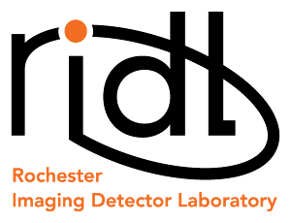 |   54 Lomb Memorial Drive, Rochester, NY 14623-5603
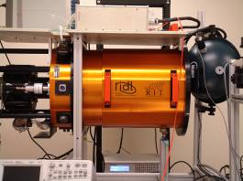 | Boeing Summer Internship  Requirements:  1 Current full time student at accredited 4 year university  2 GPA of 3.0 of better  3 Pursuing a degree in a technical field, engineering, physics, math  4 Must be completed with Sophomore year  5 Travel and Lodging expenses are the intern's responsibility  6 Must provide a current transcript  See Don Figer for further information (dffpci@rit.edu)  Inquires about this position may be directed to Dr. Donald F. Figer (figer@cis.rit.edu, Bldg.76-2246).
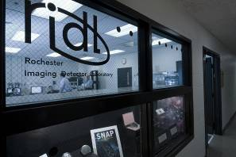



 |  |  |  |  | 
http://ridl.cis.rit.edu

